# Distance Sensor (To measure length)

1. How it works:

You must have heard of bats using echo to find their prey and avoiding obstacles while flying. Those squeaky noises you hear from the bats is actually a very small part of the sound it generates. Its voice is in the ultrasound range, which means that the frequency of its voice is so high that we cannot hear it.

So similar to a bat, this sensor sends out an ultrasonic pulse, and then detects the echoing wave. It then measures distance by taking the time taken for the echoing wave to return, multiplied by the speed of sound.

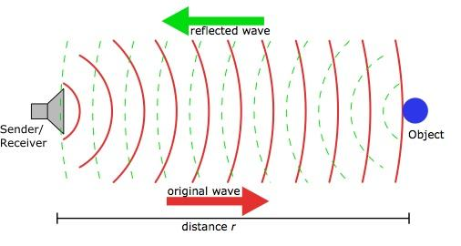

2. Applications and Specifications

This sensor is typically used where you need to give “eyes” to your project. So in robots where we need to detect and avoid obstacles. It can also be used for automatic systems such as alarms which go off when someone gets too close to something, like your personal diary.

This sensor is great for short distance measurements, but for longer distances its accuracy decreases. Also, the accuracy of this sensor is dependent on temperature and angle of the object. You will have to weigh its benefits against its limitations and use it in a project of your choice.

3. Limitations:

1. The range of the sensor is 5-200 Cm
2. If the object being measured is round, it can give wrong readings

4. Connections

1. 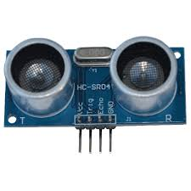Sensor Pins: There are only four pins that you need to worry about on the sensor:
2. VCC (Power)
3. Trig (Trigger)
4. Echo (Receive)
5. GND (Ground)
6. 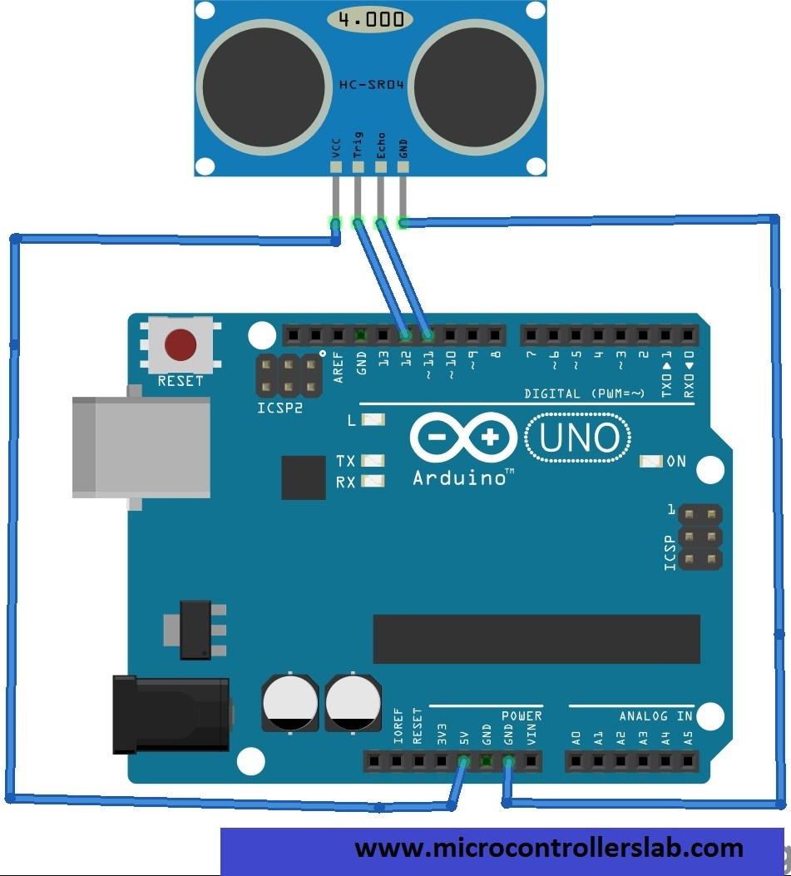Sensor pins which needs to be connected to Arduino:

|  |  |
| --- | --- |
| Arduino UNO | Ultrasonic Sensor |
| 5V | VCC |
| Digital Pin 12 | Trigger |
| Digital Pin 11 | Echo |
| GND | GND |

5. Library required for working of distance sensor: New ping

1. Search for New ping in Google
2. Go to Arduino playground website [(playground.arduino.cc/Code/NewPing)](http://playground.arduino.cc/Code/NewPing)
3. Scroll down website and select download “new ping” library.
4. A new window will open, select the “new ping_V 1.7”
5. It will come in your downloads as zip file.
6. Open Arduino IDE
7. Go to sketch>include library>add zip library
8. A new window will open, select the “New ping_V 1.7” zipped folder and click on open. The library will be added.

**6. Errors and Troubleshooting**

1. **If distance is greater than 200 cm, as defined in the code under “MAX_DISTANCE”, it will show output as 0 cm**
2. **If you are getting no readings, check your wiring. The error is almost always there**
3. **Check baud rate if the serial monitor indicates weird readings.**